FOR IMMEDIATE RELEASE

June 5, 2018

MEDIA CONTACT: Cat Manion, PR & Media Relations Manager, cmanion@paigegroup.com, (315) 733-2313

Oneida County Sewer District Scheduling Free Mohawk River Champion Presentations for Youth Summer Programs

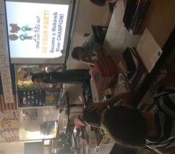
Representatives from the Oneida County Sewer District (OCSD) are now offering free educational presentations for recreation programs within the district during the months of June, July and August. This program, part of Operation Ripple Effect™, is geared toward students in third through seventh grades. Operation Ripple Effect is an Oneida County initiative aimed at helping to eliminate sanitary sewer overflows into the Mohawk River.

Into the Garden, Out of the Sewer is a program designed to show youths how anyone of any age can be a part of the solution. OCSD school program representatives engage in an interactive presentation that details what the problem is, why the problem exists and how they can become Mohawk River Champions! The presentation concludes with a fun activity and takes about 45 minutes to complete.
School Program Coordinator Shannon Rounds educates a 5th grade class at Sauquoit Valley Middle School on how they can become Mohawk River Champions.

For more information, call program representative Shannon Rounds at (315) 733-2313.
###

